INNOVATION TO PROVIDE AFFORDABLE HOUSING TO LOW INCOME GROUP USING LEAN CONSTRUCTION TECHNIQUE
Bldr. Dr Samaila Adamu FNIOB
Yobe State University Damaturu
ABSTRACT
The Nigerian construction industry fails to meet up with the challenges of providing affordable housing to its increasing populace, despite the policies and programs initiated by both public and private sector. Even the little provided tends to be below quality standard and expensive. This was ascribed to lack of adopting modern techniques to eliminate waste and non-value adding activities in the project delivery process. This paper is to evaluate the effectiveness of applying last planner system of project management in construction site and compared to traditional project management in production of low cost houses in Damaturu, Yobe State of Nigeria. A field study was conducted using action research to evaluate the effectiveness of Last Planner System of project management and compared with traditional project management in delivery of low cost houses to junior staffs. The data was collected by direct observation in the production planning and management, and interview was conducted with project participant to assess the strengths and weaknesses last planner system towards affordable housing delivery. The result shows the potentiality of last planner towards enhancing the production of affordable housing.
Key words: Affordable housing, Last planner system, waste, non-value adding activities, low income groups.
INTRODUCTION
The Nigerian construction industry fails to address the problem of housing shortages in the country, despite the number of policies, programs and strategies being engaged in by both public and private sectors. The little provided tends to be of poor quality and expensive. Where the poor income group cannot afford. The National Housing and Urban Development Policy declared that Nigerians will not pay more than 20% of their monthly income to acquire a house, (Aribigbola, 2008). The government recognises that most of the populace in need of housing are in categories of low income groups. Most of the urban population lives in dehumanising environment, and those having access to average housing do so in exorbitant cost. It was established that the challenge that affect the housing production are related, this evident a low productivity, provision of poor quality and expensive housing, (Awotona 1990; Olutuah and Bobadoye 2009). This circumstances remains to be escalating every passing day due to absence of proper monitoring and evaluation of public housing policies and programs, (Awotona, 1990). It was enunciated by extant that, the housing agencies’ failure to deliver affordable houses are mostly focussed on inability to adopt modern techniques that will enhance the project delivery process, (Bana, 1991). It was also established by Adamu, S 2017 that so called lost cost houses constructed in Nigeria tend to be high cost houses due to huge waste generation in the project delivery process. This houses can no longer be affordable to the low income groups. The low income groups in Nigeria are the greatest parentage of the Nigerian population that require affordable housing, (Mba, 1992). The Yobe State Government in effort to provide affordable housing to the junior staffs that are mostly in low income groups, initiates 1000 units of two bed rooms low cost houses that this category of staffs will afford. It engages the services of 25 contractors to handle this project. Each contractor is to construct 40 blocks within 6 months. One contactor decides to use lean construction techniques to manage the project delivery process. The idea of applying lean production to construction was analysed by construction research community since early 1990s. Koskela (1992) understand construction as production. A significant input for the formulation of theoretical base for lean construction was made by International Group for Lean Construction (IGLC). They started applying the concept of lean production to the management of construction delivery process. The construction differs from manufacturing by its nature of operation, planning and execution process. (Paez et al, 2005).
The tools of lean production cannot be used directly to manage construction process, the lean production tools are to be improved due to these differences, before their application to construction (Koskela, 1992). The most developed lean construction tool which strains the relationship between scheduling and production control is the last lanner system (LPS) which was introduced by Ballad (2000). It was indicated by Howell (1999) that lean construction is like normal practice in construction industry, as both are targeted towards customer satisfaction and reduction of resources and time waste. Lean construction differs from present practice, because is generally based on production management principles, and it gives better result in complex, uncertain and quick projects. Lean construction is not yet fully adopted in Nigeria. The main barriers to lean concept adoption in Nigeria is lack of knowledge on its benefits and procedure. (Adamu et al, 2012). It was affirm that the construction industry is hesitant to invest in research and development to improve the way things are done (Banik, 1999). Lean construction has passed the stage of development, some lean tools were tested in the field and refine over last decade. Last planner controls and manage the project delivery process, and ensures completion within schedule and elimination of waste and non-value adding activities. This research assessed the effectiveness of applying Last Planner in the production of Ten out of 40 housing unit allocated to ABK construction Ltd, and evaluated its strength and weakness towards providing affordable housing. The result will be compared with the remaining 30 houses not using lean techniques.
The paper reviews the housing delivery in Nigeria in the first part, and review the process of LPS implementation in part two. The method adopt for this research and the case study will be discussed in part three
REVIEW OF NIGERIAN HOUSING POLICIES AND PROGRAMS
Since the Nigerian independence in 1960, the government restlessly tries to provide affordable housing to its citizenry through different policies and programmes, but all effort has remained at abysmally low. As at 2018 the deficit of housing was estimated to be above 45 million housing unit, (Onwuemenyi, 2018). The government initiated programs and policies, starting from First National Development Plan (FNDP) with plan to provide affordable housing. Before the civil war in 1967, the federal government initiated to build 61,000 houses nationwide from 1962 to 1968, but only 500 units were achieved which is less than 1% of the target (Ibem, et al 2011). The Second National Development Plan designed from 1971 to 1974, with programs such as establishments National Council on Housing in 1972 to design polices and advise government on housing matters, and Federal Housing Authority (FHA) in 1973, to coordinate the provision of public housing. Plan to build 59,000 low-cost housing unit nationwide, but only 7,080 units are achieved, i.e. about 12% of the target (Ibem, et al 2011). The Third National Development Plan designed from 1975 to 1980, with converting Nigerian Building Society to Federal Mortgage Bank, and proclamation of land use Decree (1978). And formation of Ministry of Housing, Urban Development and Environment from Ministry of Works and Housing, entrust design and build low cost houses nationwide. From 1975 to 1980, planned to build 202,000 houses nationwide, but only achieved 30,000 houses, which 15% of the target (Ibem, et al, 2011). The Forth National Development Plan designed from 1981 to 1985, which include the lunching of National Housing Program to expend 1.9 billion Naira to construct 160,000 houses to low income groups in the first phase, and to construct 200,000 housing unit nationwide in the second phase from 1981 to 1985. Only 47,234 housing units (23.6%) were constructed in the first phase. The second phase was cut short by the military coup of 1983, (Ibem, et al, 2011). The military government planned to construct 121,000 houses between 1993 and 1995. A target was set to provide rural infrastructure and housing for all by the year 2000, through a program on National Housing Policy lunched to provide Nigerians access to quality housing and rural infrastructure, but the program failed. Only 5,500 housing units (less than 5%) were constructed. The Directorate of Food Road and Rural Infrastructure (DFFRRI) also fail to meet up to its targets. The emergence of civilian government in 1999, initiated another program, National Housing and Urban Development Policy (NHUDP) which was lunch by president with the mission to ensuring the accessibility of decent housing to all Nigerians through private sector-led initiative. Under this program the government planned a pilot housing project of 40,000 housing each year nationwide, and to construct 500 housing unit in each state and the federal capital Abuja under the Presidential Mandate Housing Scheme. Another arrangement construct 10,271 housing unit through different Public-Private Partnership (PPP) housing scheme nationwide. No any record of achievement from the pilot project. Only 4,440 housing units were completed in Abuja, Port Harcourt, Akure and Abeokuta through PPP. The Presidential Mandate Housing Scheme did not even take-off in the states, only 100 (about 20% planned) units were constructed in Ogun state, (Olotuah, 2010).
From the record above, literature reviewed attributed the failure of the public housing policy and programs are due inadequate and reliable information for effective housing policy formulation, program design, modern implementation strategies and techniques, and good information structure that allows for feedback, (Kellecher, 2010; F. G. of Nigeria, 1991). Poor management of housing project scheme, inappropriate design standards, waste generation contributed high cost of public housing and time overrun, (Mustapha, 2002; Ademiluyi, 2010). The effort of the public and the private sector as reported by UN-HABITAT (2006) were all targeted to affordable housing to low income groups. Nevertheless, the little provided tends to be un-affordable to the targeted group due high cost of unit constructed, (Onibokun, 1985; Awotona, 1990; Mba, 1992; Olotuah Bobadoye, 2009; Ibem, 2010).
The need to develop modern technique to housing delivery process is necessary to achieve the required objective of the housing program and policies. Last planner is a lean construction tool that ensures project are completed within time, reasonable cost and required quality that meets or exceed the user’s expectation, (Ballad, 2000).
LAST PLANNER SYSTEM OF PRODUCTION
A project objective is best achieved by governing its execution by management process, i.e. planning is followed by control. As indicated by Ballad (2000) Last Planner is a technique that shapes work flow and addresses project variables. Individual or groups that are responsible for operational planning are the Last Planners. They are responsible for structuring the product design to facilitate an improved work flow, and the completion of individual assignment at operational level. The sequence of implementation of Last Planner system set up a frame work for efficient schedule planning which shapes work flow, sequence and rate, match work flow and capacity, develop method of executing work and improves communication between trades. Schedule and budget specify should, production control translate should in to can by making schedule activities ready for assignment and eliciting a specific commitment to what will be done during next near term plan period. Therefore should, can, will are going to be achieved, which is the key term of weekly work plan. Work flow is improved by contribution of two-way communication, constrain analysis process in six weeks Lookahead before assignment is executed, analysis of reason for variance after assignment are completed, the effort of each planner and the training of project team. The difference between what should, can and will, be done is not considered at the traditional practice. It is assumed that better result will be achieved by pushing more resources, (Ballad and Howell, 2004).

The Last Planner tool evaluates the performance of workers based on their ability to meet a reliable commitment, this replace optimistic planning with realistic planning. The goal of Last Planner is pulling the activities using reverse phase scheduling through team planning and optimizes resources in long term, just as in production levelling tools in lean manufacturing.
SCHEDULES
Master schedule is the overall project schedule. In application of lean construction principle to schedules, master schedule is limited to phase milestone, special milestone, and long lead items. Phase schedule is produce with the team that will carry out the work, using a backward pass, making float explicit, and deciding as a group how to float a buffer uncertain activities. This is produced base on master schedule. And said to be Reverse Phase Schedule (RPS).
1. REVERSE PHASE SCHEDULE [RPS]
The Reverse Phase Schedule is developed from completion time of a project to planning time. To achieve proper plan that will integrate and coordinate different specialist operation, phase schedule is being developed. It also provides linkage between work structuring and production control. (Ballad and Howell 2003). (Glenn Ballard & Howell)The Last Planner team is responsible to develop reverse phase schedule. It is more accurate than master schedule. Weekly Work Plan (WWP) is also more accurate than reverse phase schedule if the actual field factor is not considered.
2. LOOK AHEAD PLANNING [LAP]
Look ahead planning is the process under take to achieve possible constraints, free assignment and cut down uncertainty. (Koskela et al, 2000). The function of look ahead planning is to shape work flow sequence and rate, match work flow and capacity, maintain a back log of ready work (workable back log), develop detail plan for how work is to be done, (operation design). (Ballad et al, 2000). Look ahead specifies the activity require to be executed in future time. In look ahead, time and schedule was estimated base on the result of reverse phase scheduling. All constraints are indicated, so that problems will be solve before production is started. (Ballad, 2000).
3. WEEKLY WORK PLAN [WWP]
Base on site condition and actual schedule weekly work plan is developed, man power requirement for each trade will be adjusted to need. The materials requirement for the period in question will be drawn in early warning chart, so that they will be delivered on the time required for work. The issue of weekly schedule, safety and quality requirement, construction methodology and any expected problem that may arise on the site will be addressed in weekly work plan meeting. Information is disseminated effectively and accurately on the project within the team. Thus, there is great improvement in productivity due to relationship of the team members. Safety, quality and resources flow are also improved. Weekly work program is reviewed to determine what assignment are completed, and if not why? The reasons are periodically analysed to their root course, and action are taken to prevent future occurrence. It should be taken as learning process than pointing fingers to team members. The cause of failure will be referring back to look ahead process for improvement of planning system, (Ballad, 2000)
4. PERCENTAGE PLAN COMPLETED [PPC]
A percentage plan completed value is the number of activity completed as planned divided by the total number of planned activities, (Ballad, 2000). If the production plan is reliable there will be positive upward slope value of percentage plan completed.
BACKGROUND OF THE STUDY
The study is based on the on the construction of 1000 housing unit by Yobe state Government of North Eastern part of Nigeria. The housing project was awarded 25 different contractors; in the State capital Damaturu. Each contractor to construct 40 units,
The project initiated by Yobe state government as pilot project of low cost houses to tackle the problem of housing affordability of low income groups in the state. The vision of this project is “Building in value to achieve the slogan of Housing for All by the year 2050”. This project was aimed at achieving affordable houses to low income groups with maximum value at the end products. One contractor among the 25 contractor applied Last Planner System to manage the production process of 10 units. The remaining contractors used traditional method to manage their project delivery process. The Last Planner was used as planning tool in the project delivery process. I monitored the application of the tool, implement the guidelines and give feedback. The 10 houses managed with Last Planner System of management had shown a significant impact in the project objective in general. Only average of 7 to 10 people are attached to each block of a house daily in order to cut down idleness. The master schedule of the project was prepared in three stages; main structure, roofing, finishing and services. The duration of the project was measured based on five working days in a week. The total duration of the project was 120 days as per master plan, it was reduced to 90 days using reverse phase schedule per each unit, going in the same time. All units implemented using last Planner System were completed within 65 to 72 days. And the remaining houses handle by the remaining team using traditional method; none was completed in less than 120 days, while not less than 15 workers attached to each unit daily.
Table 1 Schedule and completion dates
Schedules | Last Planner System | Traditional method
Master schedule | 120 days | 120days
RPS | 79 days | -
Actual completion period | 65 to 72 days | Not in less than 120 days

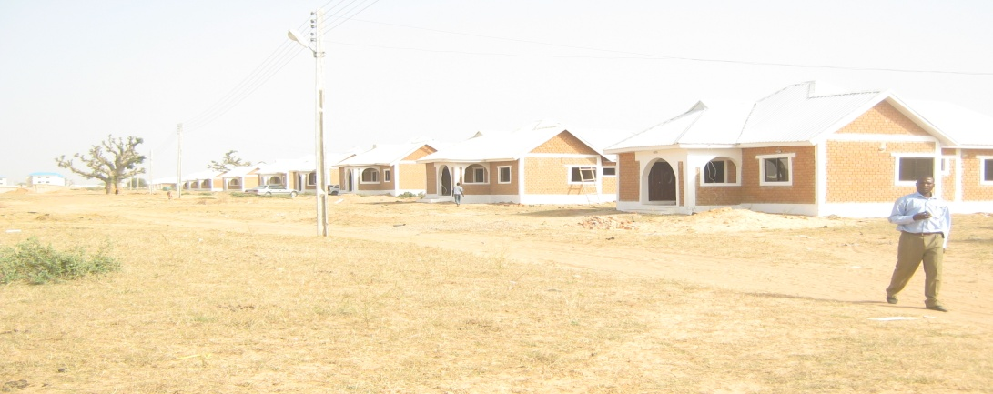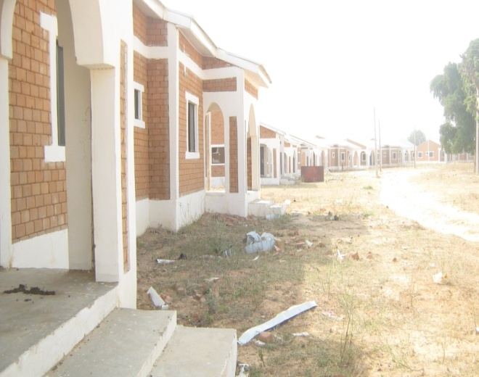
Figure 1 50 blocks fully completed within 65 to 72 days using LPS.
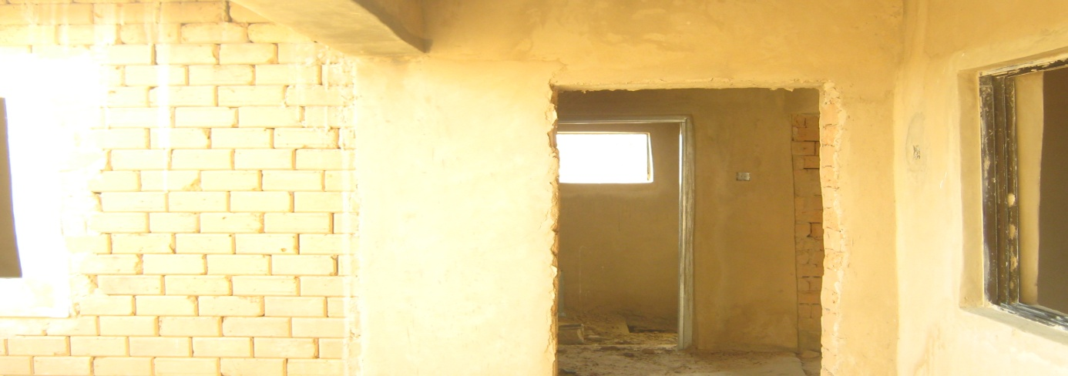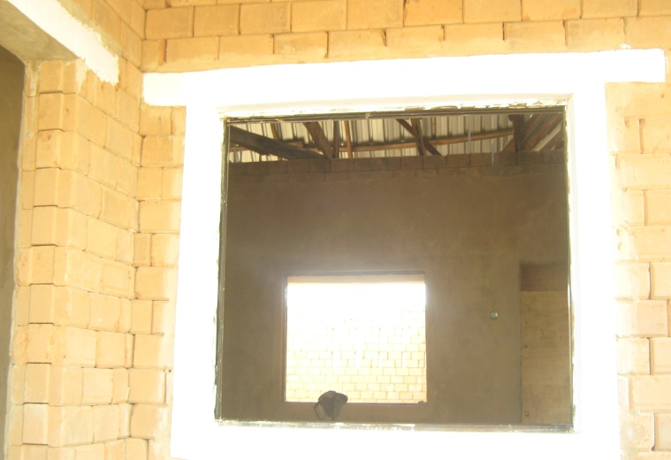
Figure 2; 250 blocks not completed after 120 days expired
METHOD STATEMENT
As a pilot project, to achieve the objective of the project, intensive study and training on Last Planner System implementations was conducted. The Last Planner System was selected for implementation in the construction of 50 houses allocated to the team out of 300 housing unit. A comparative analysis is also made with progress of other teams using traditional method. The data were collected through direct observation and interview only in the project delivery process, operation and labour utilization. The data was compiled directly from schedules and huddle meetings in the construction process. The researcher is the head of implementation team. The data collection starts from beginning to the end of the project.
The data compile on the implementation of each is based on the following;
Last Planner System | Minutes of meeting, schedules, activity and its duration, completion date as per schedule, date completed, constraints and reason for failure to complete the assignment as planned, labour employed to each activity and result of interview.
Traditional method | Schedules, activity and its duration, completion date as per schedule, date completed, labour employed to each activity and result of interview.
CONSTRAINTS AND SOLUTION
The interest is to get low-cost houses, the researcher is the team leader and the project manager, and therefore the interest of the project and the implementation Last Planner System were matched together. And the aim is achieved, but the members of the team are not familiar with lean techniques (LPS). Therefore, it became a tedious job to the project manager to monitor all activities. The team members become fed up with the new techniques during the project, but appreciated at the end. Initially the project manager has to maintain all documentation of result, including the subcontractors work, as they do not appreciate the tedious planning work and recordings. The team members expected that additional management tools are not necessary to the project objective, as it make their work more tedious. The project manager proposes an incentive to be given to committed staffs. This improves the participation of the project team to record keeping. Even though meeting were held weekly, interviews are conducted on courses of failure to meet up with schedule. Little constraints were compiled and variance were identified and addressed. The result was generally satisfactory.
FIELD SURVEY ON 50 BLOCKS OF LOW-COST HOUSING UNITS
To achieve the objective of the project, waste and non value adding activities were eliminated through a functional two way communication. With regard to this issue, the traditional scheduling method was replaced with new scheduling technique and proffer team planning using Last Planner system as shown in Figure 3.0 below.
Master schedule
Reverse phase scheduling (RPS)
Six weeks look ahead [SWLA] with constrains analysis
Weekly work plan [WWP] with backlog
Daily updated project scheduling
Variance
Plan Percentage Completed

Figure 3.0: Sequence of last planner

Master schedule was developed by the project manager base on time given to the team and previously executed projects. The schedule, drawings, early warning chart, and construction methodology were all distributed to the team members before the reverse phase schedule meeting is conducted. The LPS concept was link to the objective of the project, and the procedure was explained to the team before the RPS meeting. The team members participated in developing the RPS activity program. The logic of the activities is identified and the sequence is adjusted to requirement. Activities that dominate the critical path are identified, and the floats provided are added to activities with uncertainty in the critical path. The master schedule is the guide for RPS production. Finally a detail schedule is produced with constrains appearing. The process was observed and new detail schedule is produced.
Six week look ahead is developed by the project manager base on the result of RPS and master schedule. Constraints are recorded and analysed. SWLA is distributed to weekly work program meeting members. Members of the team participate in WWP meeting every Monday including the Honourable Commissioner of the Ministry of Housing. The WWP is compiled from the submission by different trades before the meeting. The meetings usually address the issue of planning process such as schedules, manpower, safety, construction, early warning chart and all other problems. The meetings were open and integrate two way communications.
Every week the project manager compile the actual schedule of activities executed, and update the WWP schedule and variance control table and analyzed them. Percentage Program Completed [PPC] is calculated base on start and finished time of activity and circulated to members.
RESULT AND DISCUSSION
It was verified that with proper validation of schedule for materials and labour, all the activities will be completed within schedule. Each activity that is schedule to start within next six weeks is examined, and a Lookahead window is design shorter period. As all parties that will provide the necessary information required for the work are within the project team. This gives a greater control over the work flow. All activities maintain their schedule as all constraints are removed in time. Problems are identified earlier and solved to at least maintain the Lookahead schedule, and are imposed in the production level of the project.
PERCENTAGE PROGRAM COMPLETED (PPC)
The weekly work program meeting was conducted weekly by the project team. The fifty houses were completed five days before the RPS and forty eight days before the master schedule. Sixty percent was placed as bench mark for satisfactory result of PPC and ninety percent was the highest level of PPC placed. The result was highly appreciated as no unit was completed below the bench mark, and some units were completed above the expected level marked shown in the figure below.

Figure 4.0: Percentage program completed [PPC]
All values of PPC are above 70%, as no force majeure that interrupts the schedule. The values are achieved due to incentive created to team members, two way communications, understanding and team work; problems are solved once in WWP meeting. Also the estimated schedule is based on knowledge of traditional project management, which is the main reason that activities are completed before the schedule duration. Training on lean construction approach to project delivery process will eliminate the conservative estimation. Most of the problems that arise are overcome by the project manager. Some constraints due human errors are also managed.
FINAL ASSESMENT
The lean construction technique is new in Nigeria, few professionals in the construction industry know about it. The implementation process tends to be tedious, but the fifty house constructed using lean construction approach were all completed within time with good savings in the project cost and exceeding the quality bench mark with 34.6%. Even though this assessment is pilot assessment it cannot be compared with organized implementation process. The Last planner tested was assessed based on its contribution in achieving the objective of the project. The assessment was scaled as highly impressive as compared to initial traditional method, as no single house from other groups using traditional approach was completed before the 120 days as per master schedule. The Last Planner implementation has impacted on achieving the project objective, by maintaining the schedules and saving cost through proper labour utilization, elimination of waste and non-value adding activities..
CONCLUSION AND RECOMMENDATIONS
The paper assessed the implementation of Last Planner as Lean construction approach to project delivery process in the construction of low cost houses in Nigerian. With the result achieved in the construction of the fifty houses using lean approach, it was acknowledge that with all the commitment of Nigerian government to address housing problem has only succeeded in providing insufficient number of poor quality and expensive housing. With the application of modern approaches, such as lean construction approach in the project delivery process of housing project, waste and non-value activities that contribute in escalating cost and time overrun that finally affect the cost of houses will be eliminated or minimised. The housing unit provided will be affordable. The conservative idea of management in production process that makes activities to overlap their schedules must be change for better. Once project exceed its scheduled period, the project tend to be a history. The research for addressing different problems to housing programmes using modern approaches now continues, particularly lean concepts such as schedules estimation and work program, and more tools are going to be tested in project delivery of low cost houses.
References
Adamu, S., (2017). Improving Project Delivery Process using Lean Construction Approach PhD thesis Universiti Teknologi Malaysia eprints.utm.my.
Adamu, S., Howell, G. A. & Abdulhamid, R. (2012). Adopting Lean Construction Technique in Nigerian Construction Industry. International Journal of Scientific and Engineering Research, 3(12).
Ademiluyi, I. A. (2010). Public Housing Delivery Strategies in Nigeria: A historical Perspective of Ploicies and Programmes. Journal of Sustainable Development in Africa, 12(6), 153-161.
Arigbola, A. (2008). Housing Policy Fomulation in Developing Countries; Evidence of programme Implementation from Akure Ondo state Nigeria. Journal of Human Ecology, 23(2), 125-134.
Awotona, A. (1990). Nigerian Government Participation in Housing Policy 1970-1980. Habitat International, 14(10), 17-40.
Ballard, G. (2000). Lean Project Delivery System Lean Construction Institute, .
Ballard, Glenn, & (2000). The Last Planner System of Production Control. Lean Construction
Ballard, Glenn, & Howell, G. A. (2003). Lean Project Management. Building Research and Information, 2(31), 119-133.
Ballard, Glenn, & Howell, G. A. (2004). Competing Construction Management Paradigm. Lean Construction Journal, 1, 38-45.
Bana, P. M. (1991). Housing the Urban Poor in Nigeria. The Nigerian institute of Architect, 6(1), 22-25.
Banik, G. (1999). Construction productivity improvement. ASC Proceedings 35th Annual Conference of Associated Schools of Construction. San Luis Obispo, CA., 165-178.
Howell, G. A. (1999). What is Lean Construction? Proceedings of 7th Annual Conference of International Group for Lean Construction. University of California, Berkely, CA, USA.
Howell, G. A. (2000). White Paper for Berkeley/Stanford CE & M Workshop. Paper presented at the Proceedings of construction engineering and management workshop, Palo Alto CA Stanford University.
Ibem, M.O., Anosike, M.N., & Azuh, D.E. (2011). Challenges of public housing provision in the post independence era in Nigeria. International Journal of Human Science, 8(3).
Kellecher, K. (2010). Organizational Capacity to Deliver Effective Treatment for Children and Adolecents. Administrative Policy Mental Health, 37, 89-94.
Koskela, L. (2000). An Exploration towards production theory and its application to Construction. VTT Technical Reseach center of Finland, Espoo.
Koskela, L, & Howell, G. A. (2002). The theory of project management-problem oppotunity. Working paper, VTT Technical Reseach Center of Finland and lean construction.
Lauri, Koskela. (1992). Application of New Production Philosophy to Construction. CIFC Tech. Report No. 72, Centre for Integrated Facility Engineering, Stanford University, 4-50.
Mba, H. C. (1992). The Delemmas of Housing Programmes in Nigeria. In J. U. O. a. K. O. Efobi (Ed.), Principle and Practice of Urban and Regional Planning in Nigeria (pp. 52-62). Awka: Mekslink Publishers Nigeria.
Mustapha, I. (2002). Overview of Housing and Development Programme since Independance. Housing Today; Journal of Association of Housing Corporation in Nigeria, 1(6), 28-30.
Nigeria, Federal Government of. (1991). Natioanl Housing Policy. Lagos: Federal Government Press Grigsby.
Nigeria, Federal Republic of. (1991). National Housing Policy, Lagos: Federal Government. Federal Government Press Grigsby, , 40, 973-997.
Olotuah, A. O. (2010). Housing Development and Enviromental Degeneration in Nigeria. The Built and the Human Environment Review, 3, 42-48.
Olutuah, A.O., & Bobadoye, S.A. (2009). Sustainable Housing Provision for the Urban Poor: A Review of Public Sector Intervention in Nigeria. The Built and the Human Environment Review(2), 51-63.
Onibukun, A. G. (1985). Public Housing Delivery System in Nigeria (1979 to 1983). In A. G. Onibukun (Ed.), Critical Review; Housing in Nigeria (pp. 429-446). Ibadan: Nigerian Institute of Social and Economic Research.
Onwuemenyi, O. (2008, 29 January). Nigerian Housing Sector. Punch.
Paez, O., Salem, S., Solomon, J., & Genaidy, A. (1995). Moving from Lean Manufacturing to Lean Construction: Toward a Common Sociotechnological Framework." Human Factors and Ergonomics in Manufacturing,, 15(2), 233-245.

UN-HABITAT, (2016) National Trends in Housing Production Practice 4; Nigeria, United Nations Centre for Human Settlements; Nairobi

